**

Name: _______________________________________________________________ Date of Birth: ___________________________

Email: ________________________________________________________________ Telephone: ____________________________

Address: ________________________ City: ________________________ State: ______________________ Zip: _______________

Profession: _____________________________ How do you hear about us? ______________________________________________

**Health Information**

Are you currently taking medication? ☐ Yes ☐ No If *yes*, please list current medications: _____________________________________

Are you currently under the care of a physician? ☐ Yes ☐ No If *yes*, please indicate the conditions:_____________________________

Have you had any surgeries? ☐ Yes ☐ No If *yes*, please describe:_______________________________________________________

Please indicate your emotional stress level on a scale of 0 (no stress) to 10 (high levels of stress) 0 ……..….. 10

Please indicate your physical stress level on a scale of 0 (no stress) to 10 (high levels of stress) 0 ….……… 10

*Please indicate any of the following existing conditions and health history:*

☐ headaches/migraines ☐ asthma ☐ arthritis/tendonitis ☐ sprains, strains

☐ diabetes ☐ lymphedema ☐ skin condition ☐ sciatica

☐ hernia ☐ stroke ☐ spinal/disc problems ☐ fibromyalgia

☐ high blood pressure ☐ heart attack ☐ cancer or tumors ☐ pregnant

☐ neck or back pain ☐ blood clots ☐ numbness or tingling ☐ others ____________________________

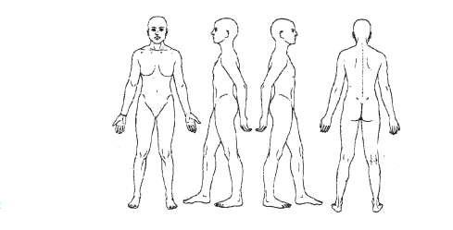

**Client consent and agreement – Please read and sign below**

* *I understand that massage therapy and Thai yoga therapy is intended for the purpose of stress reduction, relaxation, relief from muscular tension and improvement of circulation and energy flow.*
* *I understand that the service offered today are not a substitute for medical care, and my therapist is not meant to diagnose, treat or remedy any illness, disease, injury, prescribe, or treat physical or mental illness.*
* *I affirm that I have notified my therapist of all known medical conditions and injuries.*
* *I understand that massage, bodywork and energy work are entirely therapeutic and non-sexual in nature.*
* *By signing this release, I hereby waive and release my therapist form any and all liability, past, present, and future relating to massage therapy and bodywork.*

Signature ___________________________________________________ date _______________________

*On the diagrams to the right, circle any problem areas, and indicate as follows:*

tension **“T”**

pain **“P”**

surgeries **“S”**

***Madison Healing Arts Client Information***